

**YEAR: 9**

**SUBJECT: SCIENCE**

**TEST: Heat and Electricity**

**TIME: 40 minutes**

**QUESTIONS: 10 Multiple Choice (10 marks)**

**6 Short Answer (20 marks)**

**TOTAL MARKS: 30 marks**

**DO NOT WRITE ON OR MARK THIS PAPER**

**SECTION ONE – MULTIPLE CHOICE (10 marks)**

This section has **10** questions. Answer **all** questions on the separate multiple-choice answer sheet provided.

1. On a hot summer’s day a cool sea breeze is blown from the ocean to the shore. This is an example of
2. conduction.
3. convection.
4. radiation.
5. insulation
6. The current that flows in the circuit is caused by a flow of
7. electrons.
8. protons.
9. neutrons.
10. ions.
11. Which of the following materials is an insulator?
12. Copper.
13. Nichrome.
14. Rubber.
15. Aluminium.
16. The unit used to measure electric current is:
17. amperes.
18. volts.
19. ohms.
20. ammeter.
21. The instrument used to measure voltage is called:
22. an ammeter.
23. a battery.
24. a voltmeter.
25. a switch.
26. Two light globes are attached in parallel with a battery. If another light globe is attached in parallel. What would happen to the brightness of the first two globes? They would
27. get duller.
28. get brighter.
29. stay the same brightness.
30. would all ‘blow’.
31. In a torch light, the voltage comes from the
32. light bulb.
33. switch.
34. battery.
35. handle.
36. To protect people from getting an electric shock wires should be covered by
37. insulators.
38. conductors.
39. metals.
40. aluminium.
41. How does a switch turn off an appliance? It
42. stops the voltage.
43. Increases the resistance.
44. Cuts off the current.
45. Creates a closed circuit.
46. A pool blanket is used to trap heat within a pool to prevent the water from rapidly cooling down overnight. Four types of pool blanket were tested on identical pools. Each pool was heated to 28°C and at 5 p.m. each pool blanket was used to cover a pool. At 9 a.m. the following morning, the blankets were removed and the water temperature tested in each case. The results were as follows:

|  |  |  |  |  |
| --- | --- | --- | --- | --- |
| Pool blanket | Silverline | Hot stuff | Luxury liner | Thermospecial |
| Temperature at 9 a.m. (°C) | 26 | 24 | 25.5 | 23.5 |

1. The four blankets listed in order from most effective insulator to least effective insulator are:
2. Hot stuff, Silverline, Luxury liner, Thermospecial.
3. Silverline, Luxury liner, Hot stuff, Thermospecial.
4. Luxury liner, Thermospecial, Hot stuff, Silverline.
5. Thermospecial, Hot stuff, Luxury liner, Silverline.



**ANSWER BOOKLET**

**NAME:**

**FORM:** **DATE:**

Multiple Choice Short Answer Extended response Total

**/5**

**/26**

/25

**/10**

/20

**/41**

**SECTION ONE:** Multiple choice answers

Cross (X) through the correct answer.

|  |  |  |  |  |
| --- | --- | --- | --- | --- |
| **1** | a | **XXX** | c | d |
| **2** | **XXX** | b | c | d |
| **3** | a | b | **XXX** | d |
| **4** | **XXX** | b | c | d |
| **5** | a | b | **XXX** | d |
| **6** | a | b | **XXX** | d |
| **7** | a | b | **XXX** | d |
| **8** | **XXX** | b | c | d |
| **9** | a | b | **XXX** | d |
| **10** | a | **XXX** | c | d |

**SECTION TWO: Short Answer (20 marks)**

1. 1. Classify the following scenarios as either conduction, convection, or radiation. (4 marks)
2. Pauline’s arm gets warm on a summers day **Radiation**
3. The inside of a car warms when the heater is on **Convection**
4. John burns his hand on a tray as he takes **Conduction**

it out of the oven

1. A jacket prevents this **Radiation**

1. 2. **List** two advantages that parallel circuits have over series circuits. (2 marks)
   * + - **Consistent voltage**
       - **If one breaks, the other branches functional**
       - **Can have one appliance on and the other off at the same time**

3. Recall the following terms by matching each term (a to c) with its correct description ( i to iii).

(3 marks)

|  |  |
| --- | --- |
| a) current. **ii** | i) The difficulty a charge experiences passing through a material |
| b) voltage. **iii** | ii) The flow of charge passing through the circuit |
| c) resistance. **i** | iii) The energy provided to or used by charges |

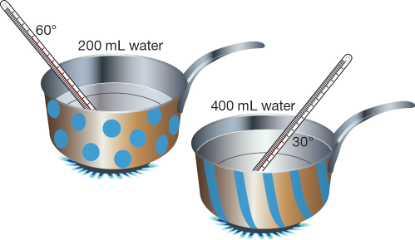4. Look at the diagram below.

1. a) Explain why the base of each saucepan is metal, but the handles are made from a tough plastic. (4 marks)

* **Metal is a conductor (1 mark)**
  + **Allows heat to pass through (1 mark)**
* **Plastic is an insulator (1 mark)**
  + **Therefore doesn’t allow heat to pass through easily (1 mark)**

b)Why does the water in the spotty saucepan heat up faster? (1 mark)

* **Less water than the other pot**

5. A torch light is made up of

* 2 cells
* An open switch
* Light bulb

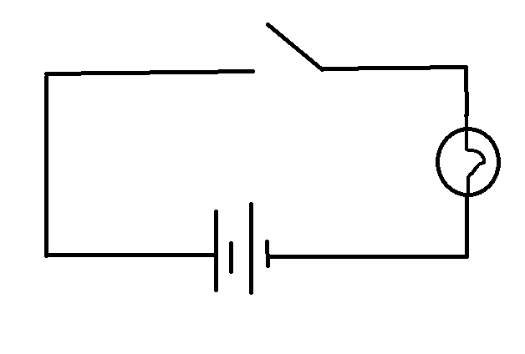a) Draw a **LABELLED** circuit diagram below (4 marks)  
  
1 - switch  
1 – light bulb  
1 – TWO cells   
1 – circuit connected

b) If each of the cells is 1.5V, what is the total voltage needed to power the torch light? (1 mark)  
**3 volts**

6. Below draw a circuit diagram of the following (4 marks)

* Voltage source / battery
* 3 light bulbs in parallel
* Switch to turn on and off ALL the lights
* Ammeter measuring the current for 1 light bulb
* 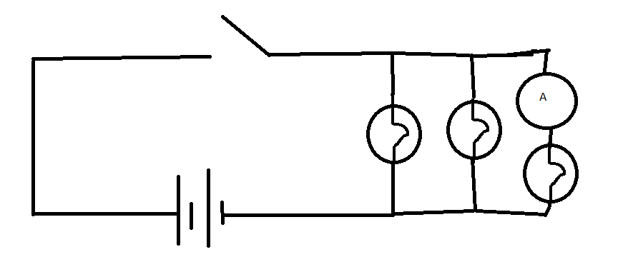  
  -1 – 3 lights in parallel
* -1 – ammeter IN SERIES with one light
* -1 – Switch located in CORRECT place
* -1 – Voltage source in CORRECT place

7. In the household, there are some measures taken when there is an overload in appliances  
a) Explain how fuses work. (2 marks)

Any two

* Fuse melts easily
* When it experiences high current
* Which stops flow of electricity (preventing damage)

b) Give a reason why short circuiting is dangerous. (1 mark)

* Damage wires or electrocute

**Part C: Extended Answer**

During the module of heat and electricity, some experiments and demonstrations were conducted during class to show static electricity.

1. How does an object become electrostatically charged? (2 marks)
2. State an experiment that was conducted during class that demonstrates static electricity (1 mark)
3. Explain an object’s movement in relation to the experiment above due to static electricity (2 marks)

**a)**

* **Rubbing (1 mark)**
* **Transfer of electrons (1 mark)**

**b)**

**Any reasonable experiment that was conducted in class. This could include**

* **Van der Graff generator**
* **Balloon + hair**
* **Balloon + plastic ring**

**c)**

**Explain attraction/repulsion (1 mark) due to like/unlike charges (1 mark)**